Southern Dinaric Cave Clam
Congeria Kusceri

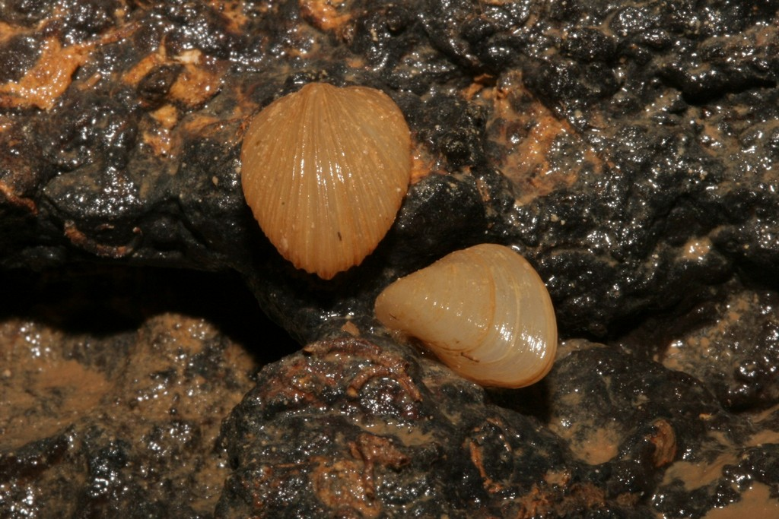
Life of the South Dinaric clam

The South Dinaric clam Congeria kusceri Bole,1962.,is one of three today's alive species of cave clam.
It inhabits submerged undeground systems spending in it its whole life, developing special adjustment.
The cave clams live either indiviudally or in clusters,firmly attached to stone walls of underground chambers and passages.They feed on small organic particles by filtering water.
The shell growth size of individuals shows the length up to 20 mm.
According to the research referring its age and growth, Congeria Kusceri is the species with long life span, but also with low growth,and the oldest examined individual from the pit Jama in Predolac was 53 years old. The males and females show no difference in terms of growth achieving the same age.
Water temperature has been identified as the main factor controlling life circle of Congeria Kusceri

The Dinaric cave clams
Genus Congeria and other three described species of Congeria kusceri Bole,1962.,C.Jazici Morton & Bilandžija,2013.,and C. Mulaomerovići Morton & Bukandžija 2013., are unique clams in the world living in subterranean waters.Also they are the only survived endemic species of Congeria, which was widely spread in tertiary time,therefore it is considered to be tertiary relic.
Living populations of DInaric cave clam have thus far been confirmed only in five localities in Croatia.Congeria Kusceri species is categorized as CR (Critically endangered) by IUCN criteria ,and is also on the European network list for nature conservation(Natura 2000,second and fourth guidelines of habitats)which implies the importance of its protection at all levels.
Pure underground waters are one of the main necessities for the life and survival of cave fauna and Congeria Kusceri in general sense,but also for humans on the surface.

Reasons for endangerment

Uncontrolled waste disposal,hydrotechnical procedures,turning and closing of natural water flows,use of herbicides and pesticides in the wider habitat space,excessive use of melioration and sea level rise caused by climate changes.

Photographs by: Vedran Jalžić

