

Info

This project work was submitted by Secondary School Metković.

Mentor – Zorana Vekić, professor, advisor

Student – Marko Baletić

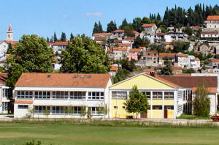

Secondary School Metković

Kralja Zvnnimira St. 12, Metković, 20350, Croatia

zorana.vekic@gmail.com

+385 20 681 712

+385 20 681 088

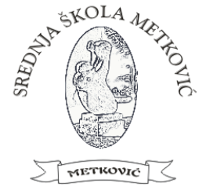

Congeria species is the only cave clam in the world.

It is also extremely rare and is hardly found in the

world, which makes the clam

**a living fossil and a tertiary relic**.

Congeria kusceri

www.ssmetkovic.hr

Secondary School Metković

Kralja Zvnnimira St. 12, Metković, 20350, Croatia

